Describe the project's objectives, IoT device setup, platform development, and code implementation.

***Project Objectives***:

The project aims to create an Internet of Things (IoT) system that allows for remote monitoring and control of various devices or processes. The primary objectives may include improving efficiency, automation, data collection, and real-time decision-making in a specific environment.

***IoT Device Setup:***

*1.Hardware Selection:*

Choose appropriate IoT devices (sensors, actuators, microcontrollers) based on the project requirements. These devices should be capable of capturing relevant data and performing necessary actions.

*2.Connectivity:*

Establish a reliable network connection (e.g., Wi-Fi, Bluetooth, LoRa) between the devices and a central processing unit.

*3.Power Supply:*

Ensure a stable power source for the IoT devices, which may include batteries, solar panels, or wired connections.

*4.Sensor Calibration:*

Calibrate sensors to accurately measure and report data. This involves adjusting sensors to provide reliable and accurate readings.

***Platform Development:***

*1.Cloud Infrastructure:* Set up a cloud-based platform (e.g., AWS, Google Cloud, Azure) to manage, store, and process data generated by the IoT devices.

*2.Database Design:* Design a database schema to efficiently store and retrieve sensor data. Consider factors like data types, indexing, and scalability.

*3.User Interface (UI):* Develop a user-friendly interface, which can be a web application or mobile app, to visualize and interact with the data. This could include dashboards, charts, and control panels.

*4.Data Analytics:* Implement data analytics algorithms for processing and deriving insights from the collected data. This might involve machine learning models, statistical analysis, or other techniques.

***Code Implementation:***

import requests

def get_air_quality_data(api_key, location):

url = f'https://api.example.com/air_quality_data'

params = {'api_key': api_key, 'location': location}

response = requests.get(url, params=params)

if response.status_code == 200:

return response.json()

else:

return None

# Example usage

api_key = 'YOUR_API_KEY'

location = 'New York'

air_quality_data = get_air_quality_data(api_key, location)

if air_quality_data is not None:

print(f'Air Quality Index in {location}: {air_quality_data["aqi"]}')

print(f'Pollutants: {air_quality_data["pollutants"]}')

else:

print('Error fetching data')

***Include diagrams, schematics, and screenshots of the IoT devices and data-sharing platform.***

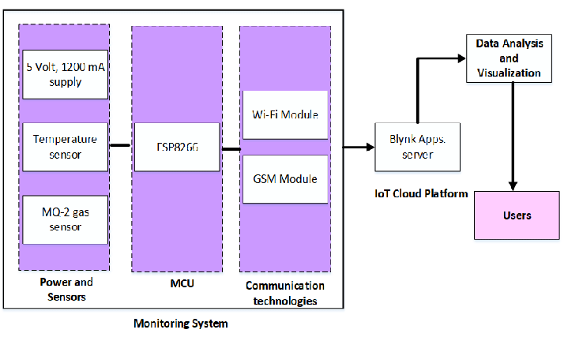

*1.Diagrams and Schematics: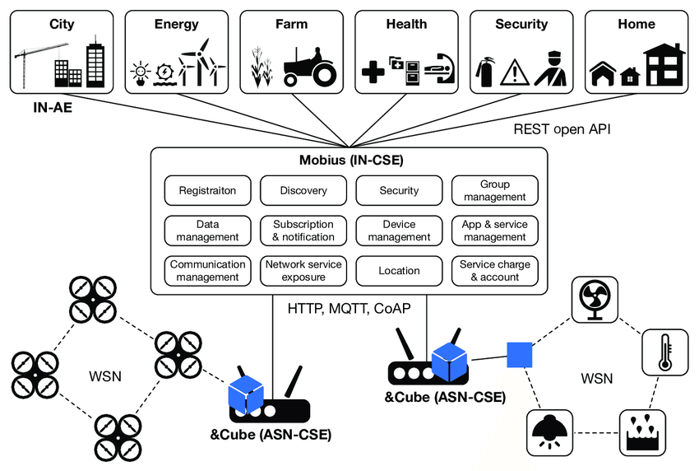*

*2.Screenshots:*If you have an existing data-sharing platform or IoT devices in development, you can take screenshots of the interfaces. Ensure you capture relevant parts of the user interface that showcase the air quality data and interaction features.

*3.Labeling and Annotations:*When creating diagrams, make sure to label each component with its name and function. This will provide clarity and understanding to anyone viewing the diagrams.

*4.Cloud-based Platforms:*If your data-sharing platform is web-based, you can capture screenshots of different pages or panels that display air quality information. Use image editing software if needed to add annotations or highlights.

*5.Hardware and Sensor Connections:In diagrams* use arrows or lines to represent the connections between different components. For example, lines between sensors and microcontrollers, or microcontrollers and connectivity modules.

*6.Platform Architecture:*

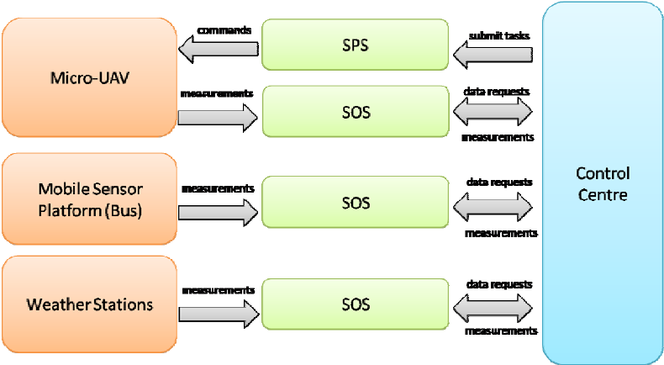

Create an architectural diagram showing how data flows from sensors through the microcontroller to the data-sharing platform. Include labels and brief descriptions to explain each step.

*7.User Interface Mockups:*If you're designing a user interface, you can create mockups using tools like Adobe XD, Sketch, or Figma. These mockups can be turned into clickable prototypes to demonstrate user interactions.

***Explain how the real-time air quality monitoring system can raise public awareness about air quality and health impacts.***

*1.Immediate Feedback:*

Real-time monitoring provides instant feedback on current air quality conditions. This immediacy makes people more aware of the air they are breathing right at that moment.

*2.Visibility of Pollution Sources:*

The system can identify sources of pollution, such as nearby factories or high-traffic areas. This knowledge can empower communities to advocate for changes and engage with local authorities.

*3.Health Alerts:*

The system can issue alerts when air quality reaches unhealthy levels. This prompts individuals, especially sensitive groups like children, elderly, and those with respiratory conditions, to take precautions or adjust their activities.

*4.Educational Opportunities:*

Publicly available data allows for educational campaigns. Schools, community organizations, and healthcare providers can use this information to teach about the effects of air pollution and the importance of clean air.

*5.Policy Advocacy:*

Armed with real-time data, advocacy groups and concerned citizens have a powerful tool to push for stricter environmental regulations and policies.

*6.Behavioral Changes:*

Awareness of poor air quality can lead people to alter their behaviors, such as avoiding outdoor activities during high pollution periods, using masks, or choosing cleaner transportation options.

*7.Community Engagement:*

The system fosters a sense of community engagement and collective responsibility for air quality. It encourages citizens to participate in initiatives aimed at improving local air quality.

*8.Media and Public Discourse:*

Real-time data can serve as a basis for news stories and public discourse. This keeps air quality issues at the forefront of public consciousness.

*9.Data-Driven Decision Making:*

Policymakers can use the data to make informed decisions about urban planning, traffic management, and industrial zoning, ultimately leading to better air quality.

*10.Public Trust and Accountability:*

A transparent and reliable monitoring system builds public trust. It holds authorities accountable for their efforts in maintaining clean air and addressing pollution sources.